Wednesday 29th July 2026
Calcot Golf Club
In aid of No.5 Young People
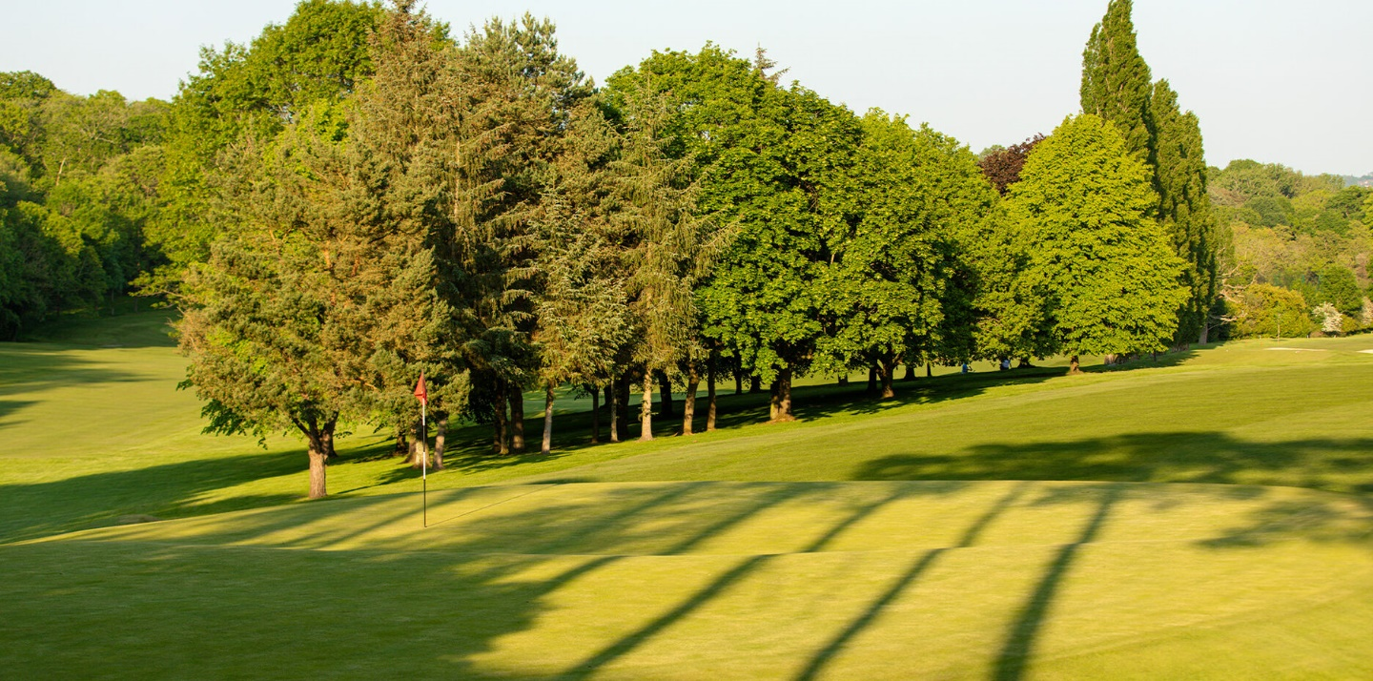
Teams of 4 –£300 which includes:
Tea, coffee & bacon rolls on arrival. Raffle & auction
A round of golf for 4 people: BBQ
format best 2 stableford scores Prize Giving
to count (full course hcp, 1st & 2nd Individuals
max 24 men, max 28 ladies) 1st,2nd & 3rd Teams
Halfway House refreshments Nearest the pin
12.00 start- two tee start Longest Drive

Calcot Park Golf Club is a historic and traditional members' golf club having been designed by the legendary Harry Colt and opened in 1930.
Situated in Berkshire on the western fringes of suburban Reading, the Club sits within an exclusive private estate. Its parkland setting only enhances the ambience of the course, one's eyes are often attracted to the ample wildlife when playing the course, whilst the changing seasons are complemented by the colours of the trees which abound the edges of the property.

Main Contact (Captain)
Name:
Address:
Postcode:
Email:
Telephone:
Player | Name | Hcp  Index | Email
Captain
Player 2
Player 3
Player 4

Please note any dietary requirements below
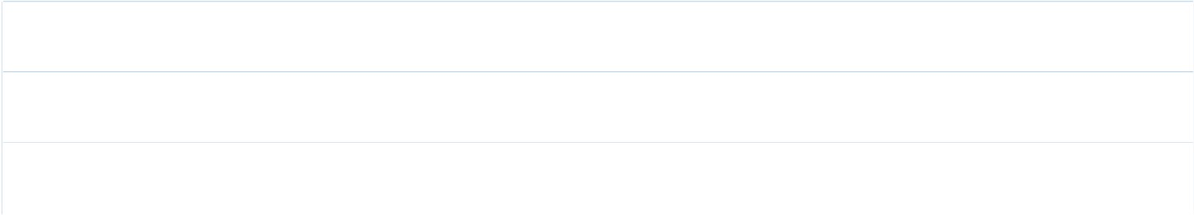
Please return completed form by 1st June via email to p.bayley12@icloud.com
An Invoice will be issued once your form has been received.

